Project Design Phase-II
Technology Stack (Architecture & Stack)
Date | 02 NOVEMBER 2025
Team ID | NM2025TMID01366
Project Name | Laptop Request Catalog Item
Maximum Mark | 4 Marks

Technical Architecture:
The deliverable includes the architectural diagram (below) and the following technical details as per Table 1 & Table 2.
Example :Laptop allocation workflow in ServiceNow for ITSM automation.
Reference: https://developer.ibm.com/articles/what-is-system-architecture-in-softwareengineering/
Architecture Description:
The Laptop Request Catalog Item automates IT asset requests and approvals in ServiceNow.
Employees can raise a request for a laptop through the Service Catalog. The workflow routes the request for manager approval, followed by IT admin fulfillment. Notifications are sent at each stage. This ensures transparency, reduces manual effort, and maintains complete asset tracking.
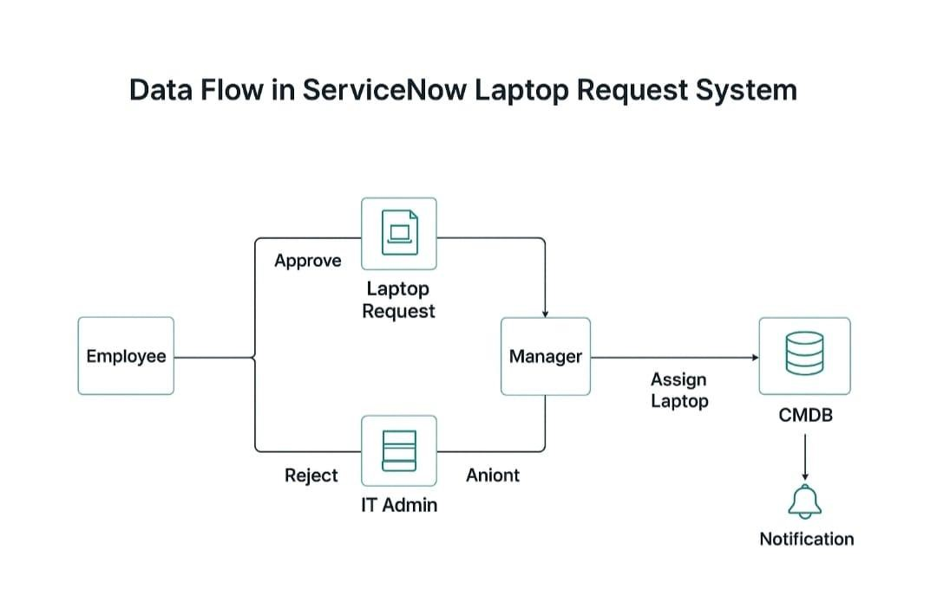

Guidelines:
Include all processes (Application Logic / Technology Blocks)
Provide infrastructural demarcation (Local / Cloud)
Indicate external interfaces (APIs, HRMS, Email, etc.)
Indicate Data Storage components / services
Indicate interface to machine learning models (if applicable)

Table 1: Components & Technologies
S.No | Components | Description | Technology
1 | User Interface | Employee submits laptop request via Service Catalog | ServiceNow Service  Portal
2 | Application Logic-1 | Captures catalog  request and routes to manager | Flow Designer
3 | Application Logic-2 | Manager approval  logic (approve/reject) | ServiceNow  Approval Engine
4 | Application Logic-3 | Assigns laptop asset  and updates inventory | GlideRecord Script
5 | Database | Stores request, approval, and asset details | ServiceNow CMDB,  Request Tables
6 | Cloud Databas | Managed via  ServiceNow backend | ServiceNow Cloud Database
7 | File Storage | Minimal; attachment logs (e.g., employee  ID proof) | ServiceNow  Attachments
8 | External API-1 | Optional integration with HRMS for user validation | REST API in ServiceNow
9 | External API-2 | Not applicable | -
10 | Machine Learning Model | Not  applicable for current use case | -
11 | Infrastructure  (Server/Cloud) | Hosted on  ServiceNow SaaS platform | ServiceNow Cloud (SaaS)

Table 2: Application Characteristics
S.No | Components | Description | Technology
1 | Open-Source Frameworks | Not applicable (ServiceNow is proprietary) | -
2 | Security  Implementations | Role-based access control, ACLs, secure scripts | Scoped Applications,  ACLs
3 | Scalable Architecture | SaaS-based, horizontally scalable  via ServiceNow | ServiceNow Cloud Architecture
4 | Availability | High availability with ServiceNow hosting | Load-balanced  ServiceNow  Instances
5 | Performance | Optimized through Flow Designer and indexed tables | GlideRecord,  Background Scripts

